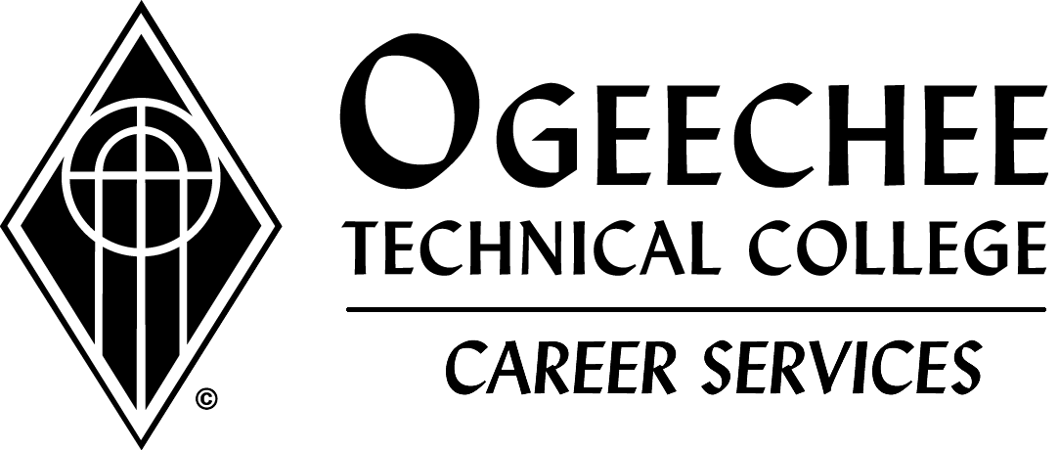
Student/Alumni Resume/References/Cover Letter Sharing Approval

I (Print Name:)__________________________________________,
(Student ID:) ______________________________, give permission for Ogeechee Technical College to submit my resume/references/cover letter (referred to as documents) to employers by any means or to use it for other uses as needed to benefit students and employers. I understand that my documents will be kept in an active file for use/submission for at least three (3) months. I understand that my documents will be kept/stored in an inactive file as mandated by State and Federal regulations for at least three years.
I agree to allow Career Services to maintain my documents on a computer hard drive or other media device for storage and use, for the reasons stated above, in addition to serving as a possible backup should I misplace my copy.
When I obtain employment or am no longer seeking employment, I agree to notify Career Services and any other office that may have my documents.

Student/Alumni Signature: __________________________________
Date: ______________________________

Equal Opportunity Institution/A Unit of the Technical College System of Georgia

